Ecolabel, Ecodesign and legislation on energy efficiency

Avv. Maurizio Iorio ©

There is much talk at present, especially in the consumer electronics industry, about energy efficiency. It is therefore important for everyone, that is to say consumers, manufacturers, importers, distributors, retailers and industry operators in general, to know the essential points of this European legislation, in that it allows the consumers to choose less energy-intensive products and the suppliers − besides producing and selling products which are more eco-friendly, respectful of natural resources and leading to economic benefits − to meet the very strict Ecodesign and Ecolabel requirements set within the EU market and thoroughly sanctioned at national level. In this article I shall examine in a summary but exhaustive and detailed manner the European and national legislation in force.

Ecolabel and Ecodesign
Let us begin by specifying that the purpose of the European legislation is to establish HOW products must be designed and constructed so as to reduce energy consumption (in this case we talk of Ecodesign or ErP – Energy-related Products, whose relevant source is Directive 2009/125/EC of 21 Oct 2009 and the related implementing delegated Regulations), and HOW the products must be PRESENTED to CONSUMERS in order to guide them and promote the sale of the most energy-efficient products (in which case we talk of Ecolabel, whose relevant source is Directive 2010/30/EU of 19 May 2010 and the related implementing Regulations).

What products are subject to the Ecolabel and Ecodesign directives?
The legislation at issue originally covered only products which, after being placed on the market and/or put into service, rely on an input of energy to operate (understood both as electricity and also as energy derived from fossil fuels or renewable sources, such as for instance photovoltaic or wind power). Only subsequently the scope of the legislation was widened to include any product – as long as, obviously, subject to specific EU regulations – that, regardless of using energy or not, have however an impact on energy consumption, such as for example a window frame or a shower head. This results in the gradual expansion of the list of products covered, which in addition to progressively including new electronic devices, it extends to products for plumbing, windows and doors, building materials.
It must be reminded that the European Commission, with a document called Swd-2012-434 published on 7 Dec 2012, has adopted, in compliance with the provisions of both aforementioned directives, a working plan for the period 2013-2014 for extending – through specific regulations to be issued – the legislation on energy efficiency to other categories of products. The related list (drawn up in English only), which is subject to changes during the two-year period and therefore not necessarily definitive, is as follows:
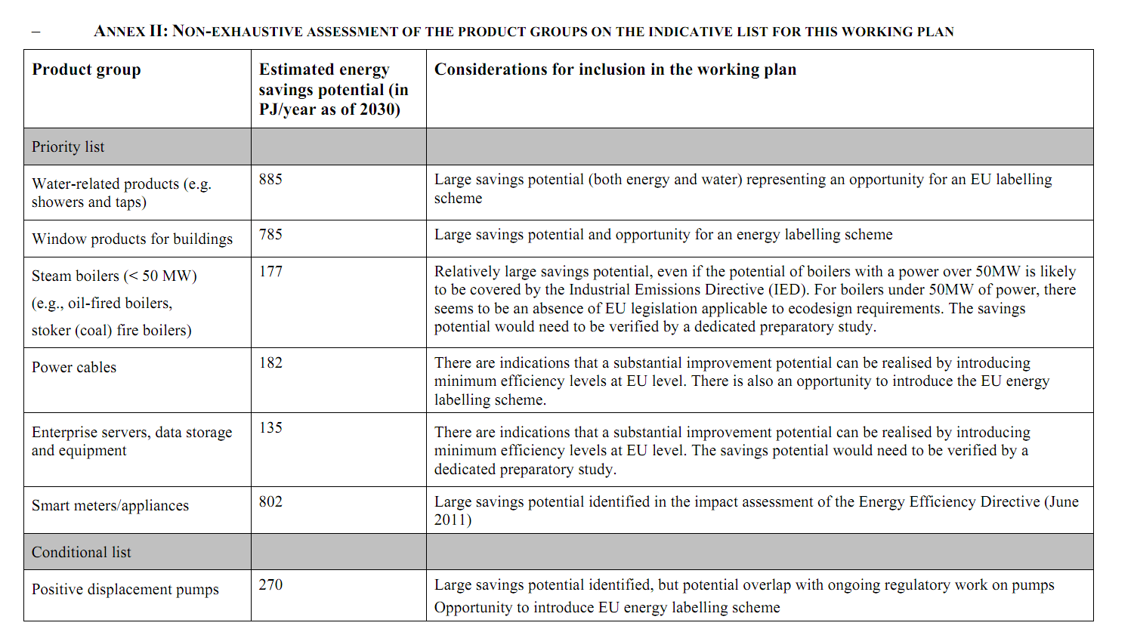
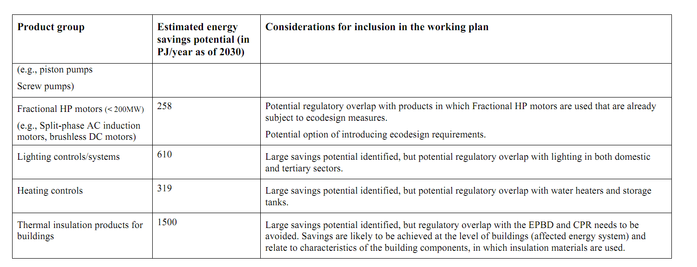

What does the Ecolabel legislation actually consist of?
From the beginning of the 90’s, a number of successive directives on energy labelling were issued (one for all: the Dir 92/75/EC). The Directive currently in force, Dir. 2010/30/EU, covers a broader range of products (which for the first time includes in its scope also TV sets) and, thus far, it has been implemented with the enactment of numerous Regulations (provided for in the Directive as “Delegated Acts” -more on which below). This Directive has moreover been implemented, as far as national responsibility is concerned (i.e., basically as regards to monitoring and sanctions), by the Legislative Decree No 104 of 28 Jun 2012, entered into force on 21 Jul 2012.
The Dir. 2010/30/EU replaces, by incorporating and amending, the previous Dir. 92/75/EC; it establishes a framework for the harmonization of national legislations on energy-related products and their consumption also through the use of labels and information on the standards of each product, for the purpose of enabling consumers to choose more wisely which are the most energy-efficient products to buy.
Specifically, it establishes as follows:
(i) - Information intended for final consumers: (1) LABEL + (2) FACT SHEET: all products put on display for sale, rent, lease, must be accompanied by a label, supplied free of charge to the reseller by the Supplier (identified in the producer or its authorized representative in the EU or, failing that, in the importer who puts the product into service in the EU or any other entity or person who places on the market or into service the products concerned), prepared in compliance with the related EU regulation and showing detailed information on the energy consumption and the assigned energy class. Moreover, all products concerned, whether put on display for sale or not, must be accompanied by pertinent fact sheet prepared by the Producer, showing detailed information on energy consumption. Finally, any form of advertising relating to the products, as well as any technical promotional material (catalogues, brochures, etc.), must provide end users with the necessary instructions for energy consumption or make reference to the specific energy class assigned to the equipment.
(ii) - Information for the authorities: TECHNICAL DOCUMENTATION: the Supplier shall preserve and keep at the disposal of the authorities for a period of 5 years from the date of manufacture of the last product concerned, its technical documentation which, besides being written in one of the official languages ​​of the EU, must be adequate to assess the accuracy of the information reported on the label and on the data sheet, and drawn up in accordance with the established parameters.

What are the EU Regulations implementing the Ecolabel Directive?
The implementation of Directive 2010/30/EU is assigned to “Delegated Acts”, i.e., Regulations to be issued by the European Commission on the basis of the mandate conferred to it by the same Directive. Below is the list of all Commission Delegated Regulations issued as at January 2014:

- Reg. No 1059/2010 of the EU Commission of 28 Sep 2010 (concerning the energy labelling of household dishwashers);
- Reg. No 1060/2010 of the EU Commission of 28 Sep 2010 (concerning the energy labelling of household refrigerating appliances);
- Reg. No 1061/2010 of the EU Commission of 28 Sep 2010 (concerning the energy labelling of household washing machines);
- Reg. No 1062/2010 of the EU Commission of 28 Sep 2010 (concerning the energy labelling of televisions);
- Reg. No 626/2011 of the EU Commission of 4 May 2011 (concerning the energy labelling of air conditioners);
- Reg. No 392/2012 of the EU Commission of 1 Mar 2012 (concerning the energy labelling of household tumble driers);
- Reg. No 874/2012 of the EU Commission of 12 Jul 2012 (concerning the energy labelling of electrical lamps and luminaires);
- Reg. No 811/2013 of the EU Commission of 18 Feb 2013 (concerning the energy labelling of space heaters, combination heaters, packages of space heater, temperature control and solar device and packages of combination heater, temperature control and solar device);
- Reg. No 812/2013 of the EU Commission of 18 Feb 2013 (concerning the energy labelling of water heaters, hot water storage tanks and packages of water heater and solar device);
- Reg. No 665/2013 of the EU Commission of 3 May 2013 (concerning the energy labelling of vacuum cleaners).

To date (January 2014) all of the above regulations are already in force, with the exception of the following:
As regards to electrical lamps and luminaires, Regulation No 874/2012 has entered into force on 1 Sep 2013, but any obligation relating to the publicity and information on the energy class shall only come into force on 1 March 2014.
As for vacuum cleaners, Regulation No 665/2013 shall enter into force on 1 Sep 2014 (except in the case of vacuum cleaners with water filter for which the entry into force has been postponed to 9 Sep 2017).

What does the Ecodesign legislation consist of?
The current Directive 2009/125/EC on energy-consuming products (as already mentioned also referred to as “Directive on or ErP ”), while repealing and extending the scope of the previous sectoral directive (Dir. 2005/32/EC on energy-using products or EuP), it also incorporates and confirms it, with the result that any EU regulation already issued in execution of this latter Directive remain completely valid.

The legislation at issue requires manufacturers or, if they are not resident in the EU or have not appointed an authorized representative established within the Community, the importers, to place on the market or put into service only products meeting the technical specifications set out by the applicable regulation and to certify their compliance through the same means provided for CE marking purposes, as follows:
(i) CE Mark affixed to each product (without the need of further markings in addition to that already required by the sectoral EC legislation), (ii) Declaration of conformity of the product in accordance with the applicable implementing measure (to be provided upon request to the authorities), (iii) a form of technical documentation drawn up in writing, to be produced upon request to the supervisory authority. No compulsory involvement of a Notified Body is required.

It is worth reminding, by the way, that also the RoHS 2 Directive (2011/65/EU) provides that the conformity of products to the requirements governed by the same be attested through the same means mentioned above (although with different content), with the result that − under a formal point of view − the CE marking does now have, for many products, a threefold meaning: (1) certification of compliance with the product’s technical regulations; (2) environmental certification in accordance with RoHS 2; and (3) certification of energy efficiency, or Ecodesign examined here.

What are the EU Regulations implementing the Ecodesign Directive?
Below are the implementing regulations in force as at January 2014 :
Commission Regulation (EU) No 813/2013 of 2 Ago 2013 - concerning space heaters and combination heaters;
Commission Regulation (EU) No 814/2013 of 2 Ago 2013 - concerning water heaters and hot water storage tanks;
Commission Regulation (EU) No 617/2013 of 26 Jun 2013 - concerning computers and computer server;
Commission Regulation (EU) No 932/2012 of 3 Oct 2012 - concerning household tumble driers;
Commission Regulation (EC) No 641/2009 of 22 Jul 2009 - concerning glandless standalone circulators and glandless circulators integrated in products;
Commission Regulation (EU) No 622/2012 of 11 Jul 2012 - amending Regulation (EC) No 641/2009;Commission Regulation (EU) No 547/2012 of 25 Jun 2012 - concerning water pumps;
Commission Regulation (EU) No 206/2012 of 6 Mar 2012 - concerning air conditioners and comfort fans;
Commission Regulation (EU) No 327/2011 of 30 Mar 2011 - concerning fans driven by motors with an electric input power between 125 W and 500 kW;
Commission Regulation (EU) No 1016/2010 of 10 Nov 2010 - concerning household dishwashers;
Commission Regulation (EU) No 1015/2010 of 10 Nov 2010 - concerning household washing machines;
Commission Regulation (EU) No 1194/2012 of 12 Dec 2012 - concerning directional lamps, light emitting diode lamps and related equipment;
Commission Regulation (EU) No 347/2010 of 21 Apr 2010 - amending Commission Regulation (EC) No 245/2009 as regards the ecodesign requirements for fluorescent lamps without integrated ballast, for high intensity discharge lamps, and for ballasts and luminaires able to operate such lamps;
Commission Regulation (EC) No 859/2009 of 18 Sep 2009 - amending Regulation (EC) No 244/2009 as regards the ecodesign requirements on ultraviolet radiation of non-directional household lamps;
Commission Regulation (EC) No 244/2009 of 18 Mar 2009 - concerning non-directional household lamps;
Commission Regulation (EC) No 245/2009 of 18 Mar 2009 - concerning fluorescent lamps without integrated ballast, high intensity discharge lamps, and ballasts and luminaires able to operate such lamps, and repealing Directive 2000/55/EC of the European Parliament and of the Council;
Commission Regulation (EC) No 643/2009 of 22 Jul 2009 - concerning household refrigerating appliances;
Commission Regulation (EC) No 642/2009 of 22 Jul 2009 - concerning televisions;
Commission Regulation (EC) No 640/2009 of 22 Jul 2009 - concerning electric motors;
Commission Regulation (EC) No 278/2009 of 6 Apr Jul 2009 - concerning external power supplies;
Commission Regulation (EC) No 107/2009 of 4 Feb 2009 - concerning simple set-top boxes;
Commission Regulation (EU) No 801/2013 of 22 Aug 2013 - amending Regulation (EC) No 1275/2008 with regard to ecodesign requirements for standby, off mode electric power consumption of electrical and electronic household and office equipment, and amending Regulation (EC) No 642/2009 with regard to ecodesign requirements for televisions.
Who is responsible for market surveillance?

The task of surveilling the market (both as regards to Ecolabel and Ecodesign) is assigned to the Italian Ministry for Economic Development (MISE), which relies on the support of the National Agency for New Technologies (ENEA).
As well as ENEA, for the official controls on matters relating to Ecolabel, MISE also uses Chambers of Commerce, the Customs Agency, the Financial Police and other “public bodies having jurisdiction in the matter ”.

What are the penalties provided for by law?

As regards Ecolabel regulations:
- The absence of the label carries a fine of EUR 3,000 to 20,000 and, in specifically foreseen cases, also the prohibition of placing on the market the products in question and/or the obligation to withdraw them from the market.
- There are also specific penalties laid down for non-compliance with the provisions set out by MISE (from EUR 4,000 to 40,000), for having affixed incomplete or inaccurate labels (from EUR 2,000 to 20,000), for having the distributor put on display products without label (from EUR 1,000 to 10,000), or with the label positioned in a not visible and legible manner, or without appropriate or not-compliant information sheet (from EUR 500 to 5,000).

As regards Ecodesign regulations:
- The placing on the market or putting into service products without CE marking or declaration of conformity is punished with an administrative penalty ranging from EUR 20,000 to 150,000 and, in case of failure to fulfil the request by the authorities to make the products compliant, the obligation to withdraw them from the market.
- There are specific penalties for failing to comply with the ban by the authorities to temporarily stop marketing products supposed to be only formally compliant (from EUR 10,000 to 50,000) and for failing to comply with the prohibition to market products that, although requested by the competent authority, were not modified to conform to the required standards (from 40,000 to 150,000). Finally, failure to produce to the requesting authority the product’s technical documentation is punished with a fine from EUR 5,000 to 30,000.

